Unified, Global, identical, inter-galactic, trans-atlantic dom testing scheme

Motivation:
The current FAT analysis is a pain. There are no well defined tool to determine quality of a DOM and ana

Requirements:
Process a large amount of data, generated by different programs in different format to judge DOM quality and produce a compact summary (“Passport”) and a “pass/fail”.
- Not a pain !!
- Simple to run
- Stand-alone – doesn’t need any special software or tools
- identical format over all sites
- documented
- Easy way to share information.
- Passport implementation
- High analysis quality

Method:
Using a set of programs each test will produce a pdf for each DOM and (a) text file(s).
The text files will be scp’ed to a window computer and import to excel to a special designed spread sheet, where the information will be summarized and prepared in a summary table.
The spread sheet will produce NCM for each failing DOM and a summary sheet for every DOM in a pdf format.
All the pdfs (from the spread sheet and from the analysis code) will be scp’ed to a special directory where they will be sorted according to DOM id and FAT into web accessible directories. Some of the pdf’s will be combined to a single pdf document – “the passport”.
The passport and all other generated pdfs will be accessible from web.

Instructions of how to run the tests are elsewhere.

Progress and development:
The analysis, passport implementation and pass/fail criteria will be reviewed by the dom-testing group. The analysis scheme will be tested in UW-FAT12 and FAT13 and evaluated on site by the UW-FAT team. The different scripts will be tuned and updated accordingly. The European sites will be provided with a ‘beta’ version of the spread-sheet and analysis scripts. All the software will be put in a public place to be used on the different sites with proper documentation.
The development is done on-site in UW.

Appendix A contains the current status of the scheme proposed here.
An ‘alpha’ version will be available for UW-FAT12, and a ‘beta’ version will be available for the European tests.

Installation and preparation

The Spread-Sheet

The Excel spread-sheet will contain the following tabs:
- Place holder for the text files: Each text file will have its own tab. A title will clearly indicate what file to import.
- Summary sheet: A summary of all the pass/fail tests from all the other tabs.
Will indicate clearly pass/fail and reason (mostly write protected)
- Summary printer: This sheet will contain the generator and template of the NCM and summary sheet (write protected)
- Pass/Fail criteria: This will contain the pass/fail criteria. Any change in this table will immediately effect the analysis (write protected)
- DFL Load table: positions (physical and electrical) of DOMs loaded to DFL with a cross-reference to the read locations. Here a cross check of dom-ids and mbids will be done.

A password will be supplied for the write protected tabs
Using Excel as the analysis tool for FATs was proven successful in all fat sites. Sample of the previous version used in UW, can vw found here:
xx link to docushare, fat 8,9,10,11xx

The file tree

The file tree is accessible by web in the html address:
http://icecube.wisc.edu/internal/domdata/
this address is accessible to all icecube users.

This address is pointed to a directory:
/www-net/xx xx
This directory is protected.
Write permissions to this directory will be give on-demand to each fat operator on all sites.
This directory is backed-up every xx xx.

FAT data
A uniform data structure on the hubs and string-processors on each site is recommended. A proposal of such directory structure follows.
At the end of each fat the ‘FAT’ directory will be moved to the /data/exp/IceCube/FAT xx check directory xx. The testdaq runs will be moved to the data-warhouse in the previously introduced manner, using the semaphore files.

Directory
To make the archiving and data analysis and retrieval easier, all sites should use the following trees on the string processor/hub for data storage during the FAT.

Each FAT will have a directory under the root.

45A

45A

DOMCal:

When:
At every temperature.
How to run:
- Using a domcal wrapper script.
- Generate histograms (can be a part of the wrapper script)
- Update db

QA:
- All DOMs were tested
- Genereate and Check the histograms.
- At least 3 points in the linear fit.
- Noise rate at 1900V should be lower than 20,000
- Check for saturation – xx jim braun to update xx
- Check for errors during the db update.

Test Output files:
- In the specified directory an .xml and an .out file are created per DOM.

Pass/Fail
- Gain too high/low
- Failed to calibrate
- HV at gain 1e7 to high/low

Data analysis
- Run the DOMcalPassport script, and point it to the -45B directory.
- Move the pdf files generated to the doms file tree.
- Export the output file to the excel spread sheet.

STF:

When:
At everey temperature
How to run:
Stf wrapper
QA:
- All DOMs
- Look for specific tests that failed in more than 5 DOMs

Pass/Fail
- Marked clearly by green/red on screen and in output files

End of tests
- Rename and move the output files.
- Generate pdf summary for the failing DOMs, and move them to the tree
Test Output files:

- File containing all the failures : STF_FAILURE.txt

- File with all the result of the tests

- If the files already exist, the information will be appended.

Data Analysis:
- Import the STF_results file to the excel spread-sheet.
- Generate specific failure summary using the STFprint script, and move pdf files to file tree.

Monitoring at changing temperature

Optical sensitivity

When:
Each temperature.

How to run:
lux-wrapper script
QA:
All DOMs
No light leak
Check that all DOMs are on from time to time.
Make sure the light source are visible by all DOMs and sync/ref boards
Check rates on ref. and sync. Board.

Pass/Fail
Sensetivity in 400 nm

End of tests
Incase of multiple runs per temperature, sort runs in directories by temperature
Run spikefinder script to remove correlated spikes (PSL) and average and fit (All sites).
Run mmdisplay, and generate reports.
Move pdf files to the file tree.

Monitoring at stable temperature:

When:
Each temperature.
Each temperature change, except the first cool-down.

How to run:
Multimon-wrapper script
QA:
All DOMs
No light leak
Check that all DOMs are on from time to time.
Check rates at ref. and synch. Boards.

Pass/Fail
Rates to high/low
Pressure too high/low
HV readback not stable
Spikes

End of tests
Incase of multiple runs per temperature, sort runs in directories by temperature
Run spikefinder script to remove correlated spikes (PSL) and average and fit (All sites).
Run mmdisplay, and generate reports.
Move pdf files to the file tree.

DOMCal:

When:
How to run:
QA:
Pass/Fail

End of tests

Test Type | Run Tool | Output files | Final place for analysis output files | Analysis Tool | Output Files for excel | Pdf created by
Rate Monitoring | multimon-wrapper | .moni file per DOM | ~/FAT20-UW/monitoring/P25A/  ~/FAT20-UW/monitoring/M45A/  ~/FAT20-UW/monitoring/M20/  …. | Spike finder  Mmdisplay | Rate-clean.txt per tempertature | Mmdisplay
Optical sensitivity | lux-wrapper | .moni file per DOM | With monitoring file | mmdisplay | 1 Optical.txt | Mmdisplay
Monitoring at changing temp | multimon-wrapper | .moni file per DOM | ~/FAT20-UW/monitoring/from25to-45/  ~/FAT20-UW/monitoring/from-45to-20/ | Spike finder  Mmdisplay | TBD | Mmdisplay (?)
DOMcal | Domcal-wrapper | .xml, .out per DOM  + update db | ~/FAT20-UW/domcal/P25A/  ~/FAT20-UW/domcal/M45A/  … | domcal-script | 1 domcal.txt  pdf per DOM | domcal-script
Local Coincidence | lcchain-wrapper |  | ~/FAT20-UW/lcchain/ |  | 1 Lcchain.txt | Not necessary
STF | stf-wrapper | Fail.out, all.out  +update db | ~/FAT20-UW/STF/  Append files to one file |  | 1 Stf_fail.txt | Manually using: makePdfStf.
Cold reboot | Reboot-wrapper |  | ~/FAT20/cold_reboot | Check with dave glowacki | 1 Cold_fail.txt | Not necessary
Optical Resolution | Testdaq | Testdaq output-.hit etc. | Record the run numbers per tempertature | Fatdisplay | 1 Optical.txt1 optical_resolution.txt | fatdisplay
Linearity | Testdaq | Testdaq output .hit etc. | Record the run numbers per tempertature |  | TBD

Progress:
 | Analysis – pass/fail | Text file generator | Pdf generator
STF | ✓ | ✓ | ✓
DOMcal | ✓ | ✓ | ✓
Monitoring | ✓ | ✓ | ✓
Optical sense. | ✓ | ✓ | ✓
Time res. | ✓ | ✓ | ✓
Monitoring changing temp
Lcchain
Cold reboot
Linearity | WIP

☑ File sorting, merging
☑ Public web page
☑ Excel spread sheet -
☑ Import setup
☑ Import test results
☑ Generate Summary and NCMs

Appendix B: DOMcal Analysis Script

The analysis script accept two parameters: Start date and FAT name.
It then loop over all xml files in the directory it was ran from, access the db, and put all the domcal info found in the db + appropriate histograms from histo/ directory for this DOM in a pdf file.
The text file will be filled with db domcal information take after the input date.

The passport requirement are to use plots from the second -45 soak. Therefore the pdf files to be use in the passport should be make from the second -45 soak directory: ~/FATxx/domcal/M45B/
and the histograms to be put here:
~/FATxx/domcal/M45B/histo

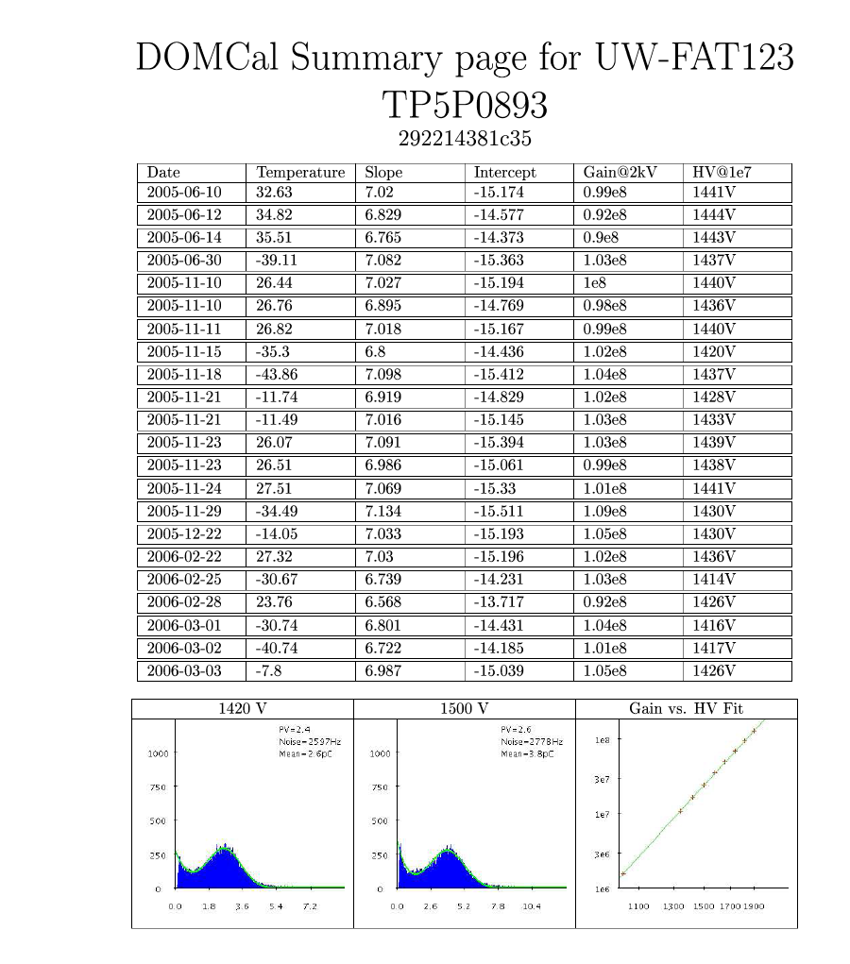

Output File: Single file to all DOMs in all temperature in the following format:
Line 1: Title | DOMcal results starting from 2006-01-01, for UW-FAT123
Line 2: Headlines | Mbid Date Temperture TempTranslation Slope Intercept
Line 3…: Data  (space delimited) | 21023f61af76 2006-02-22 27.32 room 7.03 -15.196  91c420c11953 2006-02-25 -31.42 -45 7.62 -16.57

Appendix C: STF Analysis Script

The analysis script accept three parameters: DOM-ID Start date and FAT name.
It then check all failed STF tests for this DOM after the given date.
A pdf file will be created including all DOMs STF failures.

The passport require to generate a summary of all STF failures.

Output files:
STF generate 2 output files stf_fail.txt and stf_results.txt.
stf_results will be imported to the excel sheet, where the total number of stf tests will be counted, and failures marked. Each line in those file has the following format:

date time mbid test_name Pass/Fail
11/24/05 2:53:24 PM CST 1107af0ce659 ADC.xml P

